Application Backend TASK

**Your TASKS**

You’ve got a basic spring-boot application. You can open the web interface using: <http://localhost:8080/klt>

Please create a currency converter web site which will have input fields for amount and from/to 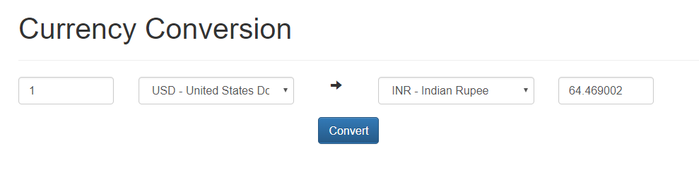currency selection you want to exchange. Web site should looks like following:

*\* it does not have to be beautiful but functional*

Use **exchange rates** API from <https://exchangeratesapi.io/> to get all the required conversion rates.

Some points to remember:

* Use this **exchange-rates** API from <https://exchangeratesapi.io/>
* Calls to **exchange-rates** API should be proxied through the application
* Design your own **currency conversion** API
* Caching of **exchange-rates** API calls